# Training Machine Learning Model on IBM Watson Studio

TEAM ID: PNT2022TMID2814

# Project - Trip Based Modelling of Fuel Consumption in Modern Fleet Vehicles Using Machine Learning

1. **Setting up Watson Studio for running Jupyter notebook**

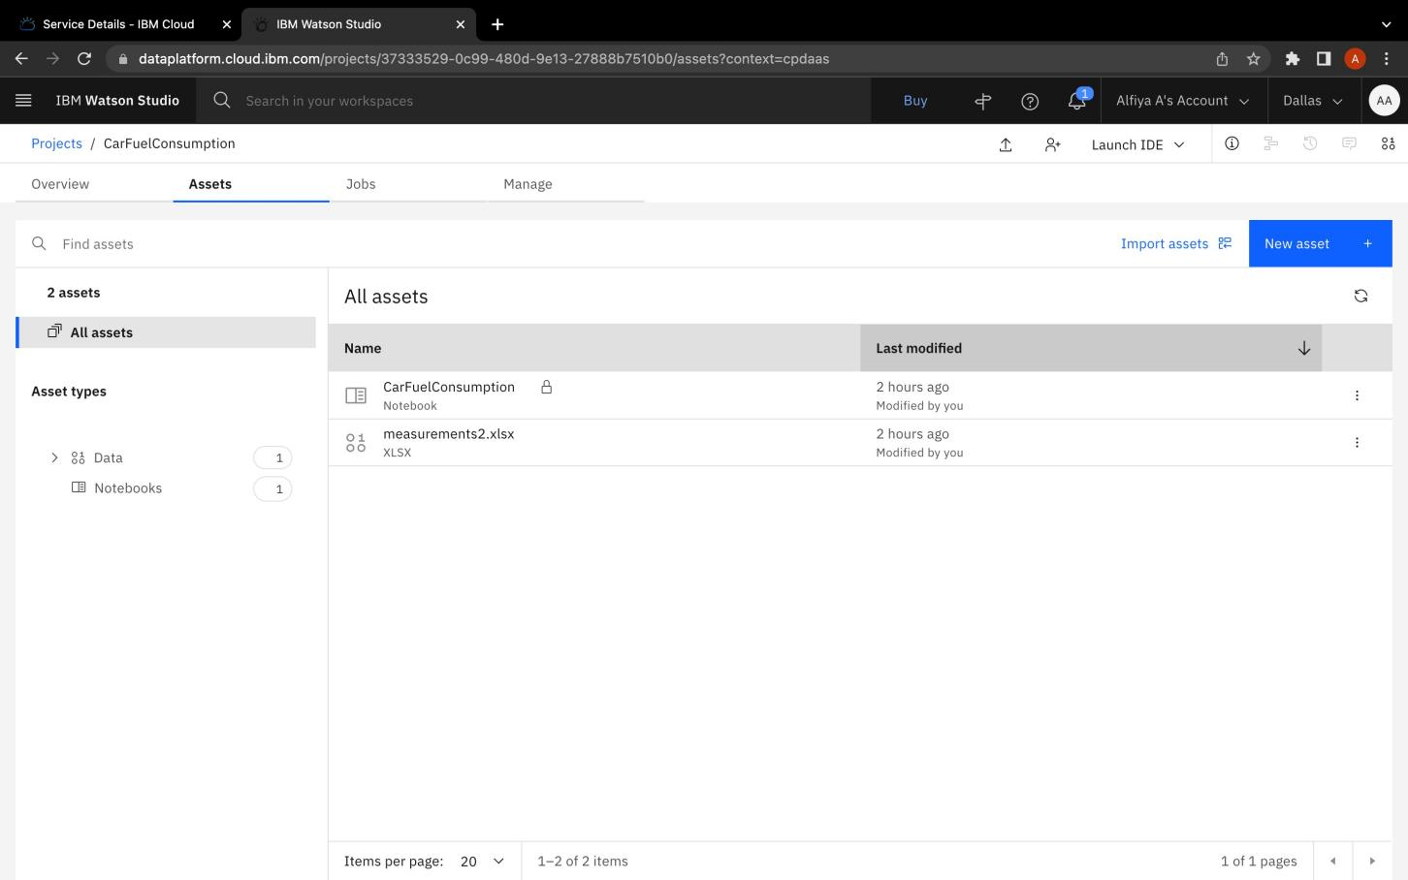

1. **Training and saving the model in IBM Watson Machine Learning Service**

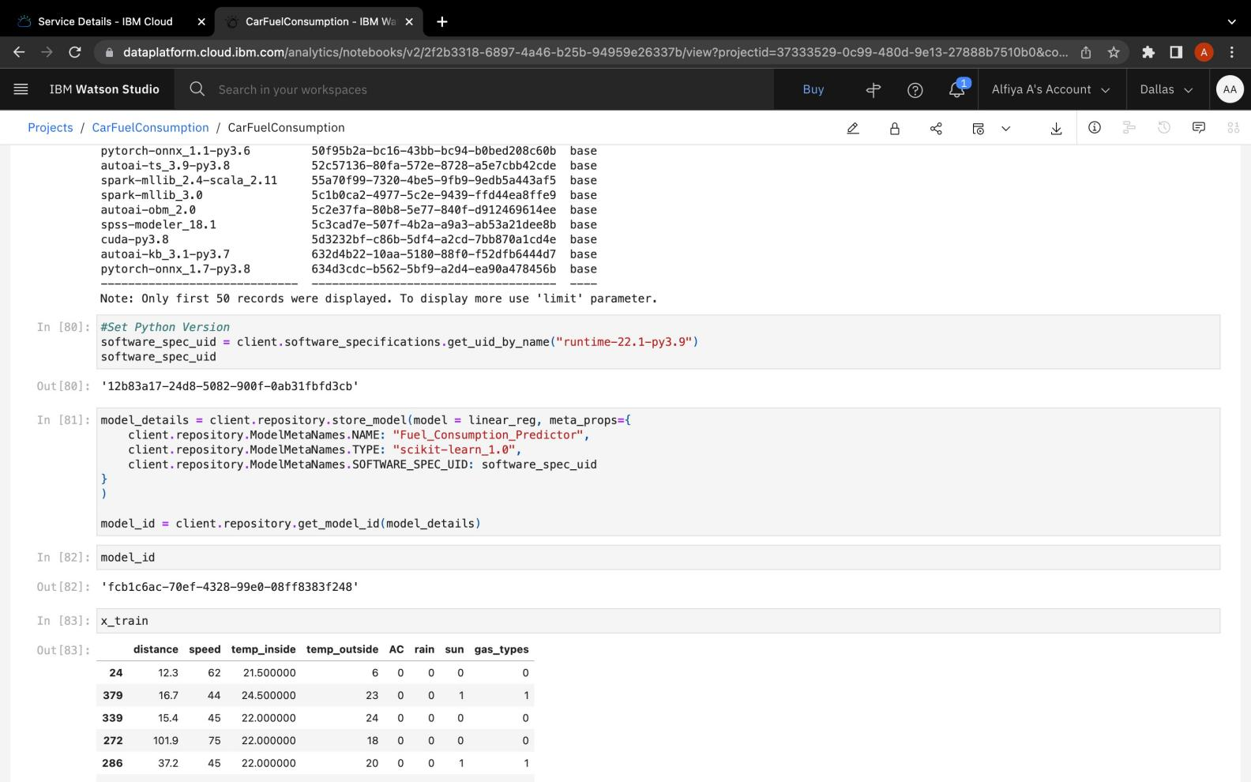

1. **Deployed the model in IBM Watson Machine Learning Service**

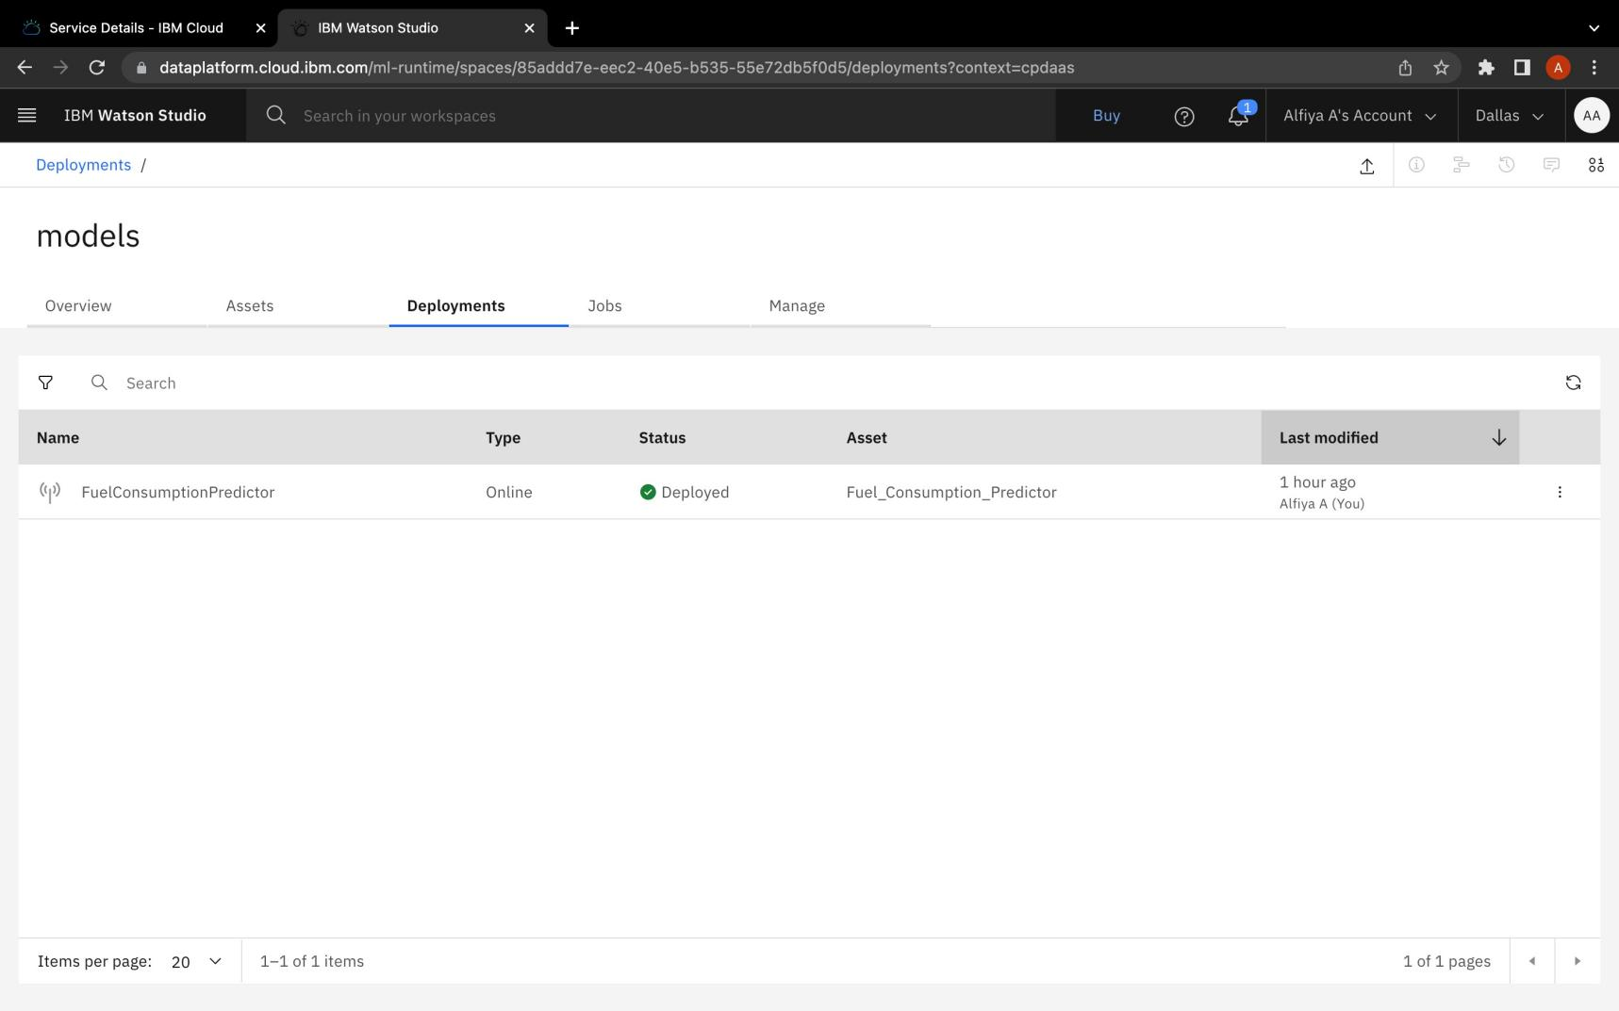

1. **Testing the created model using the API created for the deployed model**

